SESSION :- 24

QA Assignment (Part 4): Jira Defect Reporting Practice
Prepared by: QA Junior
(Note: I can't create accounts or browse the internet on your behalf, so I couldn't literally sign up for Jira — see the setup steps given in chat for Part 1. Everything below is filled out exactly as it would appear inside Jira or any defect tracker.)

2. Filled Defect Report – Real Bug in Paytm App
Field | Details
Project | Food Delivery App QA (or "Paytm Consumer App" if logged against Paytm's own tracker)
Issue Type | Bug
Summary | Transaction shows "Failed" in-app but amount is deducted from linked bank account
Description | While making a bill payment via UPI in the Paytm app, the transaction status displayed "Payment Failed, please retry" on screen. However, the bank SMS confirmed the amount was debited. No refund or auto-reversal was triggered within 30 minutes, and the transaction did not appear in Paytm's "Passbook/History" section either.
Steps to Reproduce | 1. Open Paytm app and go to "Recharge & Pay Bills" 2. Select an electricity bill payment of ₹850 3. Choose UPI as payment method and enter UPI PIN 4. Observe the result screen after PIN confirmation 5. Check bank SMS for debit confirmation 6. Check Paytm Passbook/Transaction History
Expected Result | Either the payment should succeed and reflect correctly as "Success" in the app with the transaction visible in history, OR if it fails, the amount should not be deducted from the bank (or should be auto-reversed within a few minutes with a clear notification).
Actual Result | App shows "Payment Failed," amount is deducted from the bank account, and the transaction does not appear anywhere in the Paytm app history — leaving the user with no visible record or refund status.
Severity | Critical
Priority | Highest
Environment | Android app v10.42.1, Android 14, Test performed on Jio 4G network
Attachments | Screenshot of "Payment Failed" screen, screenshot of bank SMS debit alert, screen recording of the full flow
Status | New

3. Severity vs. Priority Classification – Movie Ticket Booking App Bugs
Bug | Severity | Priority | Justification
(1) Payment fails for UPI | High | High | Severity is High because it breaks a core transaction flow (users cannot complete a booking via UPI, a very commonly used payment method), directly blocking revenue. It's not rated Critical only because other payment methods (card, wallet) may still work as an alternative — but Priority is High/Urgent because it needs to be fixed quickly given how widely UPI is used in India and the direct business/revenue impact.
(2) Movie poster image is blurry | Low | Low | This is a cosmetic/visual issue only — it doesn't block any functionality; users can still browse, select showtimes, and book tickets normally. It should be fixed for polish and brand image, but it has no functional or business urgency, so both severity and priority stay low.
(3) App crashes if you book more than 10 tickets at once | High | Medium | Severity is High because a crash is a functional failure that can cause data loss (e.g., losing seat selection or being logged out) and reflects poor app stability. Priority is Medium rather than Highest because it's a lower-frequency edge case — most users book far fewer than 10 tickets at a time — so while it must be fixed, it's less urgent than something affecting the majority of users on every transaction (like the UPI bug).
Quick rule of thumb used above: Severity = how badly the bug breaks the app/functionality. Priority = how urgently it needs to be fixed, based on business impact and how many users it affects.

5. Defect Template – Social Media App (Instagram)
Defect Template Used: Standard QA bug report template (Summary / Description / Steps / Expected / Actual / Severity / Priority / Environment)
Field | Details
Defect ID | DEF-INSTA-01
Summary | Story view count does not update in real time for close friends' stories
Description | When viewing a "Close Friends" story, the green ring and viewer count on the story remain unchanged even after multiple new viewers have watched it. The count only updates after force-closing and reopening the app.
Steps to Reproduce | 1. Post a story visible only to "Close Friends" 2. Have 2–3 other close friend accounts view the story 3. Stay on the app and check the story's viewer count without refreshing/reopening the app 4. Compare the count shown vs. actual number of viewers
Expected Result | Viewer count and viewer list should update in near real-time (or at least on pull-to-refresh) as new people view the story
Actual Result | Viewer count stays static and does not reflect new viewers until the app is fully closed and reopened
Severity | Medium
Priority | Low
Environment | iOS app v312.0, iPhone 14, iOS 17.4, Wi-Fi connection
Justification for Severity/Priority | Severity is Medium because it's a data-accuracy/display bug — it doesn't crash the app or block core functionality, but it does show incorrect information to the user. Priority is Low because it's a minor engagement-metric issue with an easy workaround (reopening the app) and doesn't affect posting, viewing, or messaging — Instagram's core flows.
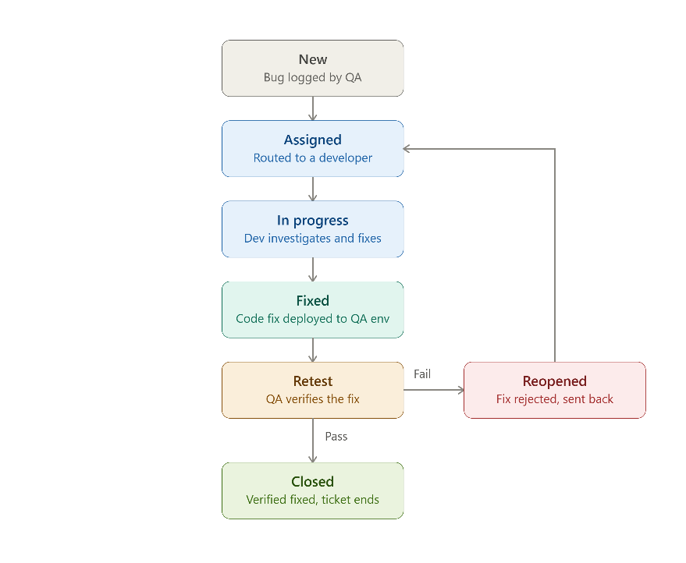

Q4):

